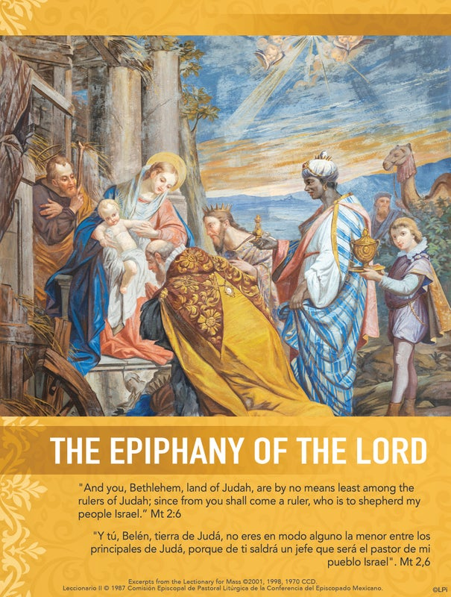
All Saints Catholic Community
1415 Dakota Street
El Paso, Texas 79930
Telephone: (915) 566-9711
ROSARY
Tuesdays/Martes 8:00 a.m.
12th day of every month 6:00 p.m.

CONFESSIONS/CONFESIONES:
Saturday/Sábado 4:30 p.m.

OFFICE HOURS/HORARIO DE OFICINA:
Monday/Lunes CLOSED
Tuesday/ Martes 8:30 a.m. – 1: 00 p.m.
Wednesday / Miércoles 8:00 a.m. – 1: 00 p.m.
Thursday/Jueves 8:00 a.m. – 1:00 p.m.
Friday/Viernes CLOSED
Saturdays/Sábado 2:00 – 5:00 p.m.
Sunday/Domingo 9:00 a.m. – 1:00 p.m.

SAFE ENVIRONMENT COORDINATORS
COORDINADORES DEL AMBIENTE SEGURO
Patricia & Ricardo Tejada

VIRTUS WEBSITE
www.virtusonline.org

PARISH CATECHETICAL LEADER
Malena Hernandez

FINANCE COUNCIL
Patrick Hoefner, Vanessa Garcia

PASTORAL COUNCIL
Santiago Romero, Vanessa García, Carmen Molina, Héctor Molina, Patrick Hoefner, Selinna Jasso, Mary Lou Romero, Andrea Baca, Richard Romero, Malena Hernández

Email: allsaintselptx@aol.com
website: www.allsaintselpaso.org
 Find us on myParish app
 Follow us on Facebook

PARISH STAFF
Fr. Mauro Muñoz, OFM, Pastor
Ms. Paula Favela, Ministries Coordinator
Ms. Sonia Favela-Esparza, Office Assistant

MASS SCHEDULE/HORARIO DE MISAS
Saturday/Sábado 5:00 p.m. English
Sunday/Domingo 8:00 a.m. Spanish
10:30 a.m. English

MINISTRY LEADERS

Choirs: Selinna Jasso, Richard Romero, Carlos Gonzalez

Lectors: Andrea Baca

Ushers: Andrea Baca

Eucharistic Ministers: Mary Lou Romero

Altar Servers: Patrick Hoefner

Liturgical Environment – Paula Favela

Prayer Group - Sonia Favela-Esparza

Guadalupana Association – Sonia Favela-Esparza

Ministry to the Sick and Homebound – Malena Hernandez

MISSION / MISIÓN

The mission of All Saints Catholic Church is to lovingly serve Christ by being a community that inspires joy, faith, and fellowship.

La misión de la Parroquia de Todos Los Santos
es de servir amorosamente siendo una
comunidad de fe, gozo, y comunión.


GOSPEL MEDITATION
The Epiphany of the Lord
Matthew 2:1-12

When I was 22, I went on a pilgrimage to Rome for the Jubilee Year of 2000. I was traveling light with just a backpack, one blue shirt and black pants, little money, and no Italian. I had a few close friends and one goal: to reach the Eternal City. Despite the challenges and deprivations, I felt alive in a way I had never known before.

When do you feel most alive? I’d wager it’s not when you’re most comfortable or surrounded by stuff. Rather, it’s when your life is aimed at something great; when you’re on a meaningful and challenging journey with good friends.

That’s the image the Magi give us in today’s Gospel. They set out from the East not with certainty, but with hope. They study the signs, discipline their attention, and journey together, offering the best they have when they find the newborn King.

The Church gives us their story at the start of the year to reawaken something in us. We are not meant to drift. We’re meant to journey as pilgrims. The Jubilee Year of 2025 may have ended, but our pilgrimage has not. Like the magi, the closer we get to Christ, the more alive we become.

— Father John Muir ©LPi

THE EPIPHANY OF THE LORD JANUARY 4, 2026

.m.


STEWARDSHIP REFLECTION
EPIPHANY OF THE LORD
“Then they opened their treasures and offered him gifts of gold, frankincense, and myrrh.” Matthew 2:11
The image of the Magi kneeling before the infant Jesus and opening their treasure chests for Him is an image that we should all try to follow each day. In gratitude for all that we have been given, we are called to generously share all our gifts, not just the ones we pick and choose. God wants us to be generous with everything, but especially that one thing that means the most to you.

EPIFANÍA DEL SEÑOR
“Entonces abrieron sus cofres y le ofrecieron sus regalos de oro, incienso y mirra” MATEO 2:11
La imagen de los Magos arrodillados ante el niño Jesús, abriendo los cofres y los tesoros que tenían para Él, es una imagen que todos debemos tratar de seguir cada día. En agradecimiento por todo lo que hemos recibido, somos llamados a compartir con generosidad todos nuestros dones, no solo aquellos que escogemos. Dios quiere que seamos generosos con todos ellos, pero especialmente con aquel que tiene más significado para nosotros.

Parish Stewardship – December 27 & 28, 2025
Sunday Collection $ 1,137.00
Online Sunday Collection $ 130.00
Building Fund $ 0.00
Online Building Fund $ 0.00
Christmas Collection $ 940.42
Online Christmas Collection $ 848.00

This week, the Blessed Sacrament Perpetual Candle is lit in For the Special Intention of
Maria Elena Reynozo
Saturday, January 3, 2026– 5:00 pm
Deceased Daughters of Charity
+Miguel and Andrea S. Reyes by Reyes Family
+Evangelina Reyes by Reyes Family
+Susan Ramelli by Reyes Family
+Rita Bentley by Favela Family
For the Health of Malena Hernandez by Parishioners

Sunday, January 4, 2026 – 8:00 am
Alicia Pérez-Barrio Por su Salud
por Elvia y Sonia Hernández
Por la Paz del Mundo por Elvia y Sonia Hernández

Sunday, January 4, 2026 – 10:30 am
+Victoria Quezada by Nohelia Chavez
+Jesus Quezada by Nohelia Chavez
+Catalina Chavez by Nohelia Chavez
+Roberto Chavez by Nohelia Chavez
Brian Forman for Healing of his Eyes by Irmgard Forman

MEDITACIÓN DEL EVANGELIO
La Epifanía del Señor
Mateo 2:1-12

Hoy celebramos la Solemnidad de la Epifanía, y el evangelio narra la presencia de tres reyes magos que buscaban a Jesús para adorarlo y llevarle regalos. “Al entrar en la casa, vieron al niño con María, su madre; se arrodillaron y lo adoraron. Abrieron sus cofres y le ofrecieron regalos de oro, incienso y mirra” (Mateo 2:11). Los magos representan a todos los pueblos y razas. La misericordia de Dios queda manifestada en su Hijo. “Señor Dios, que en este día manifestaste a tu Unigénito a las naciones guiándolas por la estrella, concede a los que ya te conocemos por la fe que lleguemos a contemplar la hermosura de tu excelsa gloria…” (Oración colecta).

El evangelio nos dice también que los magos, al ver la estrella de nuevo, se llenaron de alegría. ¿Qué estrella seguimos nosotros? ¿Quién nos orienta? Cabe reflexionar un poco sobre la misión de la Iglesia, que es llevar la luz del Evangelio a todos y a todas las culturas. Entonces, ¿cuál es mi misión específicamente? Será favorecer la Epifanía, es decir, manifestar a Dios desde nuestro entorno y vocación con sencillez y humildad. Vivimos en un mundo de retos y de mucha violencia, donde los derechos y la dignidad humana son pisoteados por los Herodes de nuestro tiempo. Nuestra tarea es seguir luchando para que tu Luz brille en las tinieblas y la esperanza siga viva en cada hijo e hija tuya que te busca con fe para adorarte. Porque Tú eres para todos.
©LPi

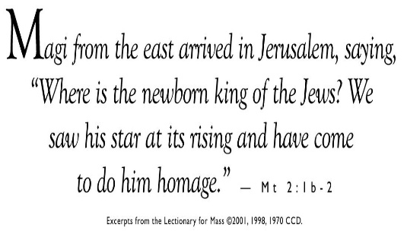
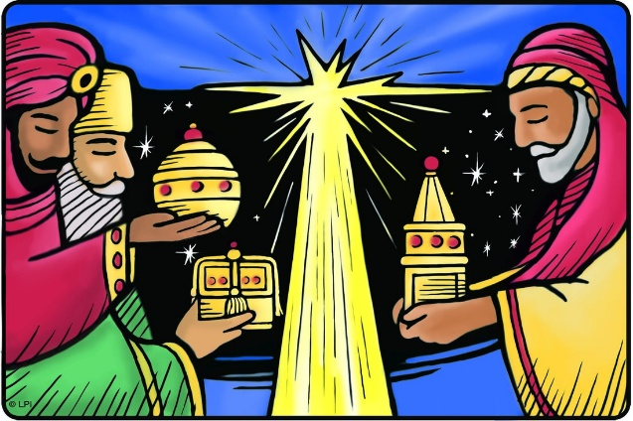
LA EPIFANÍA DEL SEÑOR 4 DE ENERO DE 2026

REMOVING CHRISTMAS DECORATIONS
Please join us after mass on Sunday, January 11, 2026, as we prepare for the end of the Christmas season. We will be taking down the Christmas decorations at this time. All help is welcome.

VIRTUES, EXPLAINED!
Love - Mini Explanation
The virtue of love seeks the good of the other, a reflection of the love of God who created us for this very purpose. In practicing this virtue, we express the fullness of our identities as sons and daughters of God. In true Christian love, we find freedom.
Love, Explained!
If you’ve ever been a guest at a Christian wedding, chances are you have heard 1 Corinthians 13:4-8: “Love is patient, love is kind ... love never fails.”
But what and who we love is just as important as how we love. Loving God, we know, is the greatest commandment of Jesus Christ, followed by loving others (Matthew 22:37-40). We are called to exhibit this love even — and, perhaps, especially — when it is difficult, when it demands we sacrifice our own preferences, our own desires and our own prejudices (Matthew 5:46).
In doing this, we “no longer stand before God as a slave, in servile fear, or as a mercenary looking for wages, but as a son responding to the love of him who ‘first loved us.’” (CCC 1828)
So yes, love is patient, and love is kind — and, when practiced correctly, love is also freedom. ©LPi

IN MEMORY OF RITA BENTLEY
It is with great sadness that we share the passing of Rita Bentley on December 18, 2025. Rita brought so much light and love into our parish community and will be deeply missed by all who knew her. Our condolences to her family, especially her daughter Antoinette. Her services are as follows:
January 6, 2025 – 5:00-9:00 p.m., Funeraria Del Angel, Montana; recitation of the Rosary will be at 6:30 p.m.
January 7, 2025 – 11:30 a.m. – Funeral Mass, Chapel of Loretto, 1300 Hardaway
JANUARY COLLECTIONS:
January 10 & 11 - Building Fund
January 17 & 18 - Priests’ Retirement
January 24 & 25 - Collection for the Church
in Latin America
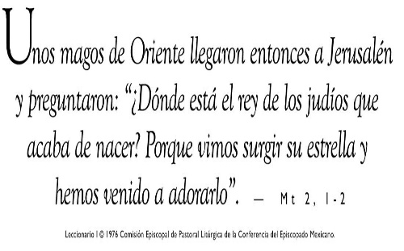

RETIRO DE LA DECORACIÓN NAVIDEÑA
Los invitamos a acompañarnos después de la misa del domingo 11 de enero de 2026 para preparar el final de la temporada de Navidad. Ese día retiraremos las decoraciones de Navidad. Toda ayuda es bienvenida.

VIRTUDES, ¡EXPLICADO!
Amor - Mini Explicación
La virtud del amor busca el bien del otro, reflejo del amor de Dios que nos creó para este mismo propósito. Al practicar esta virtud, expresamos la plenitud de nuestras identidades como hijos e hijas de Dios. En el verdadero amor cristiano, encontramos libertad.
Amor, ¡Explicado!
Si alguna vez has sido invitado a una boda cristiana, es probable que hayas escuchado 1 Corintios 13:4-8: "El amor es paciente, el amor es benigno... el amor nunca falla". Pero qué y a quién amamos es tan importante como cómo amamos. Sabemos que amar a Dios es el mayor mandamiento de Jesucristo, seguido de amar a los demás (Mateo 22:37-40). Estamos llamados a exhibir este amor incluso —y, quizás, especialmente— cuando es difícil, cuando exige que sacrifiquemos nuestras propias preferencias, nuestros propios deseos y prejuicios (Mateo 5:46).
Al hacer esto, "ya no estamos ante Dios como esclavos, en temor servil o como mercenarios en busca de salario, sino como hijos que responden al amor de Aquel que 'nos amó primero'". (CIC 1828)
Así que sí, el amor es paciente y el amor es amable, y, cuando se practica correctamente, el amor también es libertad. ©LPi

Epiphany Blessing
Dear God,
It was You who inspired the Magi to follow the star to find You. Inspire us to seek You, as well. Bless our homes and families this season, make them places where we can encounter You through prayer and community.
Amen.

